**LAB: 11**

Q.1 Write a program illustrating function with no arguments and no return values.

**Program**

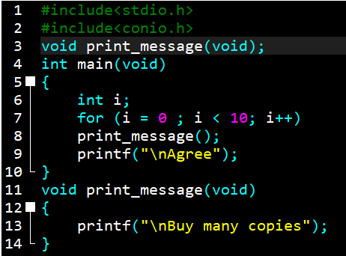

**Output**

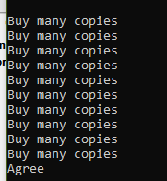

Q.2 Write a function illustrating with arguments but no return values.

**Program**

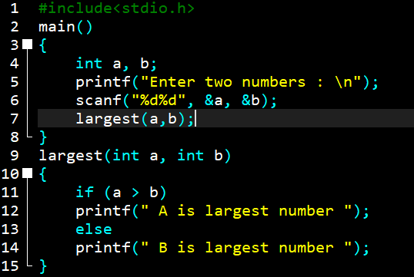

**Output**

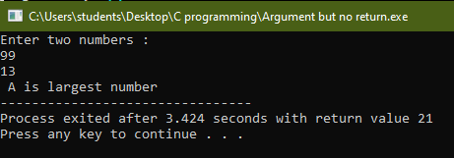

Q.3 Write a function illustrating function with arguments and return values.

**Program** 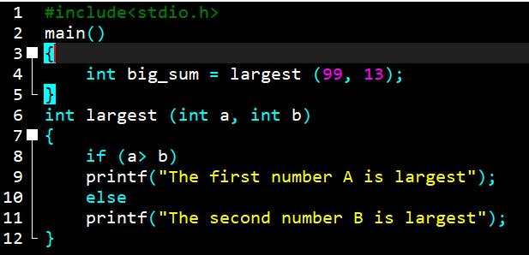

**Output**

